Evolution of

Digital Photography

and the

Digital Camera

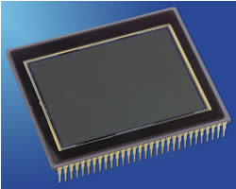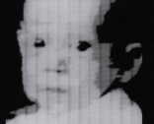

Steve Sasson, an engineer at Kodak, invents the first ever digital camera was a fairly rudimentary affair compared to what we use today.

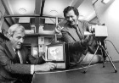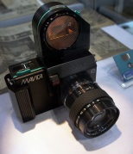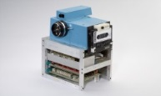

19698

At Bell Labs, George Smith and Willard Boyle invent the Charged Couple Device (CCD), the image sensor that is one of the main components of the digital camera. A year later, the CCD was built into the world’s first solid state camera.

19868

19818

19758

19578

The first prototype digital camera is produced by Sony called the Mavica. It records images as magnetic impulses on a compact 2inch floppy disc.

Kodak scientists invent the first megapixel sensor, capable of recording 1.4 million pixels.

The first digital image is produced on a computer by Russell Kirsch for the United States National Bureau of Standards created a rotating drum that allowed images to be scanned. Using this device, he scanned a 5 centimeter by 5 centimeter shot of his son into the computer.

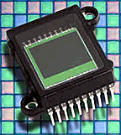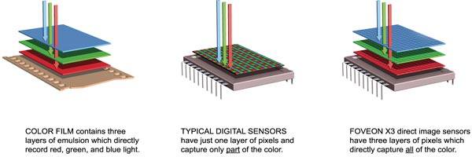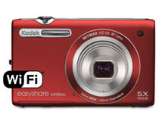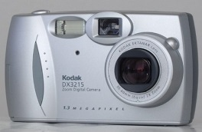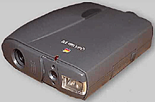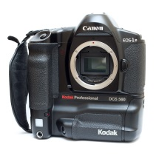

Foveon produces a new image sensor. In this image sensor, individual photosites' (these are the pixels of the sensor) collect information about *either* red *or* green *or* blue light.

2012

Kodak puts out digital cameras that didn’t have to be connected to a computer in order to download and share pictures by using wifi. This is done by using the cameras Easy Share method.

Kodak puts out their Easy Share digital camera, making it easy to snap pictures and download them to the computer.

2001

1994

The Apple QuickTake 100 camera, the first digital cameras for the consumer-level market that workes with a home computer via a serial cable. This camera featured a 640 x 480 pixel CCD which produced eight images stored in internal memory. It also had a built-in flash.

19918

19908

Kodak releases the first professional digital camera system (DCS), aimed at photojournalists. It was a Nikon F-3 camera equipped by Kodak with a 1.3 megapixel sensor.

Logitech comes out with the Dycam Model 1 black-and-white digicam, the world's first completely digital consumer camera. It stored 32 compressed images internally using 1MB RAM on a 376 x 240 pixel CCD at 256 shades of gray in TIFF format.